PROJECT

Control LEDs using an IR sensor and a remote

In this project, we are going to control LEDs using an IR sensor and a remote. The IR sensor is a 1838B IR receiver. Whenever a button on the remote is pressed, it will send an infrared signal to the IR sensor in the coded form. The IR sensor will then receive this signal and will give it to the Arduino.

Circuit and Working

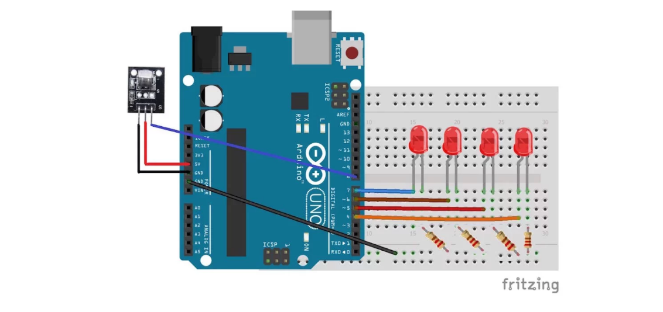

PIN CONNECTIONS

First, connect the four LEDs to the Arduino. Connect the positives of the four LEDs to the pins 7, 6, 5, and 4. Connect the negative of the four LEDs to GND on the Arduino through the 220 ohm resistors. The longer wires on the LEDs are positive and the shorter wires are negative.

Then connect the IR sensor to the Arduino. The connections for the IR sensor with the Arduino are as follows:

* Connect the negative wire on the IR sensor to GND on the Arduino.
* Connect the middle of the IR sensor which is the VCC to 5V on the Arduino.
* Connect the signal pin on the IR sensor to pin 8 on the Arduino.

WORKING

Whenever a button is pressed on the remote, it sends an infrared signal in encoded form. This signal is then received by the IR receiver and given to the Arduino.

We will save the code for the buttons that we want to control the LEDs in the Arduino code. Whenever a button on the remote is pressed, the Arduino receives a code. The Arduino will compare this code with the codes already saved, and if any of them match, the Arduino will turn on the LED connected to that button.

CODE

#include <IRremote.h>

#define first_key 26775

#define second_key 51255

#define third_key 43095

#define fourth_key 10455

int receiver_pin = 8;

int first_led_pin = 7;

int second_led_pin = 6;

int third_led_pin = 5;

int fourth_led_pin = 4;

int led[] = {0,0,0,0};

IRrecv receiver(receiver_pin);

decode_results output;

void setup()

{

Serial.begin(9600);

receiver.enableIRIn();

pinMode(first_led_pin, OUTPUT);

pinMode(second_led_pin, OUTPUT);

pinMode(third_led_pin, OUTPUT);

pinMode(fourth_led_pin, OUTPUT);

}

void loop() {

if (receiver.decode(&output)) {

unsigned int value = output.value;

switch(value) {

case first_key:

if(led[1] == 1) {

digitalWrite(first_led_pin, LOW);

led[1] = 0;

} else {

digitalWrite(first_led_pin, HIGH);

led[1] = 1;

}

break;

case second_key:

if(led[2] == 1) {

digitalWrite(second_led_pin, LOW);

led[2] = 0;

} else {

digitalWrite(second_led_pin, HIGH);

led[2] = 1;

}

break;

case third_key:

if(led[3] == 1) {

digitalWrite(third_led_pin, LOW);

led[3] = 0;

} else {

digitalWrite(third_led_pin, HIGH);

led[3] = 1;

}

break;

case fourth_key:

if(led[4] == 1) {

digitalWrite(fourth_led_pin, LOW);

led[4] = 0;

} else {

digitalWrite(fourth_led_pin, HIGH);

led[4] = 1;

}

break;

}

Serial.println(value);

receiver.resume();

}

}

